General Welfare Requirement: Safeguarding and Promoting Children's Welfare
The provider must take necessary steps to safeguard and promote the welfare of children.
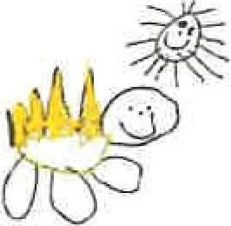
Gorran Pre School
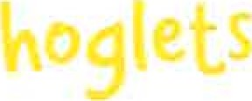
Safeguarding Children
1.6 Uncollected child
Policy statement
In the event that a child is not collected by an authorised adult at the end of a session/day, Gorran Pre-School Hoglets staff puts into practice agreed procedures. These ensure the child is cared for safely by an experienced and qualified practitioner who is known to the child. We will ensure that the child receives a high standard of care in order to cause as little distress as possible.
Gorran Pre-School Hoglets inform parents/carers of our procedures so that, if they are unavoidably delayed, they will be reassured that their children will be properly cared for.
EYFS key themes and commitments
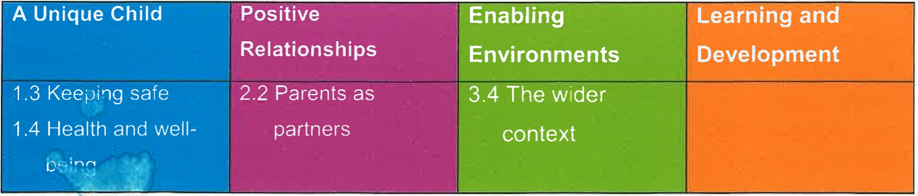
Procedures
Parents of children starting at Gorran Pre-School Hoglets are asked to provide the following specific information which is recorded on our Registration Form:
- Home address and telephone number - if the parents do not have a telephone, an alternative number must be given, perhaps a neighbour or close relative.
Place of work, address and telephone number (if applicable).
Mobile telephone number (if applicable).
Names, addresses, telephone numbers and signatures of three adults who are authorised by the parents to collect their child from the setting, for example a childminder or grandparent.
- Who has parental responsibility for the child.
Information about any person who does not have legal access to the child.
- On occasions when parents are aware that they will not be at home or in their usual place of work, they inform us in writing of how they can be contacted.
On occasions when parents or the persons normally authorised to collect the child are not able to collect the child, they provide us with written details of the name, address and telephone number of the person who will be collecting their child. We agree with parents how to verify the identity of the person who is to collect their child.
Parents are informed that if they are not able to collect the child as planned, they must inform us so that we can begin to take back-up measures. We provide parents with our contact telephone number.
We inform parents that we apply our child protection procedures in the event that their children are not collected from Hedgehogs by an authorised adult within one hour after preschool has closed and the staff can no longer supervise the child on our premises.
- If a child is not collected at the end of the session/day, we follow the following procedures: The child's file is checked for any information about changes to the normal collection routines.
If no information is available, parents/carers are contacted at home or at work.
- If this is unsuccessful, the adults who are authorised by the parents to collect their child from the setting - and whose telephone numbers are recorded on the Registration Form
- are contacted.
- All reasonable attempts are made to contact the parents or nominated carers.
The child does not leave the premises with anyone other than those named on the
Registration Form or in their file.
If no-one collects the child after one hour and there is no-one who can be contacted to collect the child, we apply the procedures for uncollected children.
We contact our local authority children's social services care team:
01872 322 000 (telephone number)

- The child stays at Gorran Pre-School Hoglets in the care of two fully-vetted workers until the child is safely collected either by the parents or by a social care worker.
Social Care will aim to find the parent or relative if they are unable to do so, the child will become looked after by the local authority-
Under no circumstances do staff to go to look for the parent, nor do they take the child home with them.
A full written report of the incident is recorded in the child's file.
- Depending on circumstances, we reserve the right to charge parents for the additional hours worked by our staff.
Ofsted may be informed:
08456 404040 (telephone number)
Our local Pre-school Learning Alliance office/Pre-schooI Development Worker may also be informed.
(name and telephone number)

Other useful Pre-school Learning Alliance publications

- Safeguarding Children (2010)
Held on: October 2019
Date to be reviewed: October 2020
Signed on behalf of the management
Gorran Preschool Hoglets

Michelle Beard

committee

Name of signatory Michelle Beard

Role of signatory (e.g. chair/owner) Pre-School Leader/Nominated Person

